**ISSUE:**

**PVC order is CLOSED, still ICORE status is in CONTRACTED instead of IN-SERVICE**

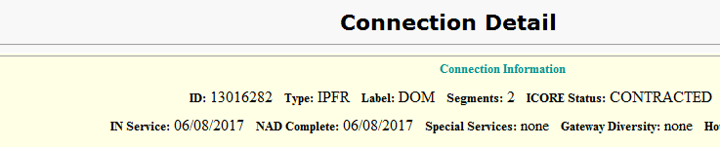

**Solution:**

For a Multiorder flow if PVC is closed and still ICORE showing status as CONTRACTED , carryout the following steps:

🡪Open Task Summary in ICORE GUI or use below query in DB to check whether **Cutover** task is completed or not.

-------------

SELECT ots.*

FROM workflow_dba.order_task_state ots

WHERE ots.order_version_id=( SELECT max(order_version_id) FROM workflow_dba.order_version WHERE order_id=1001064812 ) *-- give LPP order id from Order Detail page*

ORDER BY status_date DESC ;

--------

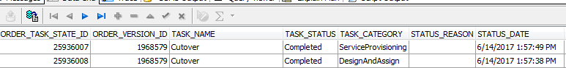

🡪 As we can see **Cutover** is already completed, we need to open the order using Undo NAD option on the Order detail page (if no access to do, ask the user)

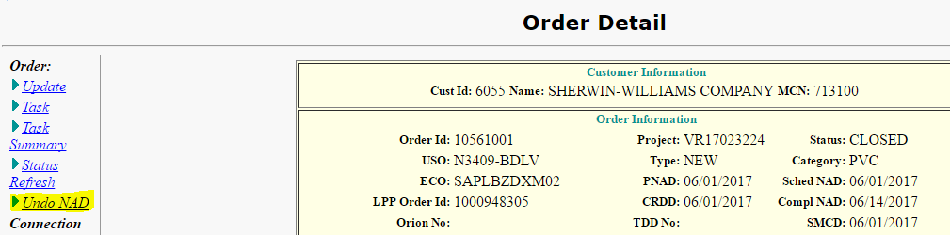

🡪 On successful Undo NAD, UndoCutover task completes and the order gets OPEN



🡪 Do **Apply Order** to redo the cutover and this closes the PVC order again.

🡪 Now check the status again, it should be IN-SERVICE

